**2020 Fish Transportation Collection Raceway Total Dissolved Gas (TDG) Monitoring**

**By Eric Hockersmith and Darren Pecora**

**Abstract**

From April 3 through June 21, 2020 Snake River dams spilled to 125% total dissolved gas (TDG) for a minimum of 16 hours per day and at a reduced amount for the remaining 8 hours under the Flex Spill Agreement. TDG in forebays of Little Goose and Lower Monumental dams ranged from 100% to 129% during this time. Elevated TDG exposure above 110% can lead to gas bubble disease (GBD) which may reduce fish health and lead to mortality. The effects of GBD can be reduced or delayed with increased depth such as when fish sound, however, smolts collected for transport are held in relatively shallow raceways for up to 48-hours with limited opportunity for depth compensation. We monitored TDG levels in the transport collection raceways during the spring 2020 under the Flex Spill Agreement operations to assess TDG exposure. TDG in the Little Goose transport collection raceways was ≥ 110% approximately 60% of the time and in the Lower Monumental Dam raceways ≥ 110% TDG 15% of the time.

**Introduction**

The U.S. Army Corps of Engineers (USACE) juvenile fish transport program collects smolts passing through the juvenile bypass systems (JBS) at Lower Granite, Little Goose and Lower Monumental dams and transports them to below Bonneville Dam during the spring. Fish are collected and either held in raceways or direct loaded into a transport barge. Holding times before being transported are up to 48-hours dependent on when fish enter holding facilities. The goal of this investigation was to determine TDG exposure levels for fish that are collected in transport raceways at Little Goose and Lower Monumental dams during the 2020 spring Flex Spill Operations (April 3rd to June 21st). The raceways at Lower Granite Dam were not examined because forebay TDG levels rarely are above 105%.

Fish and water pass from the forebay into a gatewell and then exit the gatewell into a collection channel. The supply water for the raceways is excess water removed from the JBS by a dewatering facility located between the collection channel and bypass flume. Neither the supply system nor the raceways have degassing systems. The number of raceways and capacity vary by project and are described in Table 1.

McGrath et al. (2006) reported that short-term exposure up to 120% TDG does not produce significant effects on migratory juvenile or adult salmonids when compensating water depths are available. Transported smolts have limited opportunity for depth compensation because raceways are relatively shallow (Table 1).

Spill operations during the 2020 spring Fish Operation Plan (FOP) are outlined in the Flex Spill Agreement (2018) and consisted of spill to a gas cap of 125% daily average TDG in the tailrace at each dam for a minimum of 16-hours per day from April 3rd to June 21st. Spill continued during the remaining 8-hours, but at a reduced volume. The timing and duration of the reduced spill varied by day and project throughout the season.

**Methods**

Hydrolab MS5 Mini Sondes (sondes) were used to monitor water quality in a transport collection raceway at Little Goose and Lower Monumental dams during the spring FOP. The sondes were outfitted with membrane diffusion method TDG sensors, thermometers (thermistor), luminescent dissolved oxygen, conductivity and depth sensors. Sondes were calibrated in the USACE Walla Walla District water quality lab prior to deployment following standard operating procedures (Eaton et al. 1998, HACH 2006). Sondes were deployed at approximately mid-depth in monitoring locations. After the sondes were retrieved from the field, a post-deployment calibration verification was performed on all sensors. Parameters were recorded every 15 minutes throughout the evaluation from April 3 through June21, 2020. Each raceway monitoring system included a barometer for calculating TDG.

Sondes were deployed downstream of the raceway 10 tail screen at Little Goose Dam, and downstream of the raceway 3 tail screen at Lower Monumental Dam to assess TDG conditions in fish holding raceways. Raceway TDG data was compared to TDG in the project forebay which was collected via the water quality (WQ) monitor at a depth of approximately 52 feet. The raceways at Lower Granite Dam were not monitored in 2020 because dams above Lower Granite Dam are located sufficiently upstream so that their spill operations are unlikely to influence TDG levels in the forebay or raceways at Lower Granite Dam. Spill operations at Lower Granite Dam influences TDG levels in the forebay of Little Goose Dam and spill operations at Lower Granite and Little Goose dams influences the TDG levels in the forebay at Lower Monumental Dam. TDG in the raceways was analyzed for the period from April 3, through June 21, 2020.

**Results**

TDG levels in the forebay and raceways at Little Goose and Lower Monumental dams are presented in Tables 2 and 3 and Figures 1, and 2. The daily average forebay TDG at Little Goose Dam ranged from 101.3% to 121.7% and averaged 114.6% from April 3rd to June 21st (Table 2) while the raceway TDG ranged from 101.3% to 115.8 and averaged 110.2% (Table 3). TDG in the raceway at Little Goose Dam ranged was ≥ 110% approximately 60% of the time (Table 3). The daily average forebay TDG at Lower Monumental Dam ranged from 100.7% to 128.2% and averaged 119.3% while the raceway TDG ranged from 102.0% to 111.8% and averaged 108.2% during this same time period. TDG in the raceways at Lower Monumental Dam was ≥ 110% approximately 15% of the time (Table 3). Forebay and raceway TDG levels were well correlated (Figures 1 and 2) providing the ability to predict raceway TDG levels for various forebay TDG levels. The estimated raceway TDG resulting from various forebay TDG levels at Little Goose and Lower Monumental dams using the regression equations in Figures 3 and 4 is presented in Table 4.

**Discussion**

Elevated TDG supersaturation can cause GBD that can lead to physical injury or mortality. GBD severity is a function of TDG exposure level and duration with higher concentrations and increased duration of exposure causing higher severity (Weitkamp and Katz 1980). GBD signs and effects can be reduced or delayed with increased depth such as when fish sound. McGrath et al. (2006) reported that when compensating water depth is available, TDG levels up to 120% for short-term periods do not produce significant effects on juvenile or adult salmonids. In general, 10% TDG compensation occurs with each 1 meter in depth (Maynard 2008). Thus for 120% TDG at the surface, TDG would be 110% at 1 m deep and 100% at 2 m, etc.

The fish transport collection raceways are 5 ft deep (1.5 m), providing little opportunity for depth compensation. Tiffan el al. (2009) hypothesized that added stressors such as collection and handling combined with exposure to relatively low TDG levels (cyclic daily TDG swings from 102% to 109%) resulted in acute mortality for subyearling Chinook salmon held for less than 48 hours at depths < 1m.

The USACE transport operations collect and hold smolts in relatively shallow raceways for up to 48 hours before transporting. Mesa et al. (2000) found that yearling Chinook salmon held in 120% TDG had 20% mortality within 40 to 120 h and juvenile steelhead within 20 to 35 h. At 130% TDG, 20% mortality occurred in 3 to 6 h for yearling Chinook salmon and 5 to 7 h for juvenile steelhead. They did not observe any mortality for fish held 22 days when TDG was 110%. During the 2020 spring FOP spill operations, TDG exceeded 110% approximately 15% of the time in the Lower Monumental raceways and 60% of the time in the Little Goose raceways. At Lower Monumental Dam an orifice plate in the 36” water supply just upstream of the raceway headbox reduces TDG levels of the supply water. The Little Goose raceway water is supplied by a 24” line and does not have an orifice plate to provide similar degassing capability. An assessment in 2019 of the Little Goose 24” raceway supply found that adding an orifice plate upstream of the raceway headbox would reduce the water volume below the amount needed to operate the holding facility at full capacity.

Although the USACE has not directly observed increased mortality related to GBD for fish collected and held in raceways for transport, delayed effects may be occurring particularly for fish held in the raceways and transported from Little Goose Dam when TDG levels are elevated. Indirect mortality related to GBD can result in increased vulnerability to predation (Mesa and Warren 1997) and susceptibility to disease (Weiland et al. 1999). The relationships between indirect effects of long-term chronic exposure to elevated TDG such as increased stress, susceptibility to disease, reduced growth, vulnerability to predation, or delayed mortality are poorly understood (McGrath et al.,2006).

Options to reduce Little Goose raceway TDG levels could include operational changes or structural modifications. Funding to study, design, and structurally modify raceway source water TDG levels are not currently available. Since GBD severity is a combination of TDG exposure level and duration, operational changes that decrease exposure duration during periods of high raceway TDG would likely be the least costly and easiest to implement in the short term. Direct loading where fish are held in the transport barges rather than the raceways would reduce exposure to elevated TDG when collecting and holding smolts for transport at Little Goose Dam because the barge water supply pumps keep the barge hold TDG below 110%. In 2020, collected smolts at Little Goose Dam were direct loaded into a transport barge when possible. Direct loading operations are dependent on debris amounts due to constrictions in direct loading hoses and flumes and personnel limitations. The time smolts were held in the raceways was minimized to reduce exposure times to the higher raceway TDG during periods when direct loading was not occurring.

Raceway TDG at Little Goose Dam was elevated above 110% frequently and for sustained periods of time during the 2020 spring Flex Spill Operations. Future transport operations at Little Goose Dam should continue to direct load when possible to reduce transport fish exposure to elevated raceway TDG under the Flex Spill Operations. Elevated TDG above 110% was infrequent and of short duration in the raceways at Lower Monumental Dam thus the 2020 spring Flex Spill Operation did not appear to be a concern at Lower Monumental Dam for collection and holding of smolts for transportation. The average river flow during the 2020 spring FOP was 11% below the previous 10-year average (88.6 kcfs versus 99.2 kcfs). During years when flows are above average, raceway TDG levels are anticipated to be higher than those observed during 2020 particularly at Little Goose Dam.

**References**

Eaton, A. D., Clesceri, L. S., Greenberg, A. E., & Franson, M. A. H. 1998. Standard methods for the examination of water and wastewater. 20th ed. 1998. Washington, DC: American Public Health Association.

Flexible Spill Agreement. 2018. available at: <https://www.bpa.gov/efw/FishWildlife/SpillOperationAgreement/doc/ECF-2298_Spill-Notice-and-Agreement.pdf>

HACH. 2006. Hydrolab DS5X, DS5, and MS5Water Quality Multiprobes User Manual: February 2006, Edition 3. Available at: <https://s.campbellsci.com/documents/ca/manuals/series_5_man.pdf>

Maynard, C. 2008. Evaluation of Total Dissolved Gas Criteria (TDG) Biological Effects Research: A literature review. WA State Department of Ecology Publication 08-10-059.

McGrath, K. E., E.M. Dawley, and D. R. Geist. 2006. Total Dissolved Gas Effects on Fishes of the Lower Columbia River. PNNL-15525. Report to U.S. Army Corps of Engineers Portland District, Portland, Oregon Contract DE-AC05-76RL01830. 40 p.

Mesa M. G., L. K. Weiland, and A. G. Maule. (2000). Progression and Severity of Gas Bubble Trauma in Juvenile Salmonids. Transactions of the American Fisheries Society, 129:174-185.

Mesa, M. G., and J. J. Warren. 1997. Predator avoidance ability of juvenile Chinook Salmon subjected to sublethal exposures of gas supersaturated water. Canadian Journal of Fisheries and Aquatic Science 54:757–764.

Tiffan, K. F., W. P. Connor, B. J. Bellegraph, and R. A. Buchanan. 2009. Snake River fall Chinook salmon life history investigations annual report 2008. Report to Bonneville Power Administration, Portland, OR. Project number 200203200.

Weiland, L. K., M. G. Mesa, and A. G. Maule. 1999. Influence of infection with Renibacterium salmoninarum on susceptibility of juvenile spring Chinook Salmon to gas bubble trauma. Journal of Aquatic Animal Health 11:123–129.

Weitkamp D.E. and Katz M. (1980). A review of dissolved gas supersaturation literature. Transactions of the American Fisheries Society109, 659-702.

Table 1. Volume and capacity of fish collection raceways for transport by project.

|  |  |  |  |
| --- | --- | --- | --- |
|  | **Lower Granite** | **Little Goose** | **Lower Monumental** |
| **Number of Raceways** | 10 | 10 | 4 |
| **Maximum depth (ft.)** | 5 | 5 | 5 |
| **Inflow (gal./min)** | 1,200 | 1,200 | 2,400 |
| **Volume (gal.)** | 12,000 | 12,000 | 24,000 |
| **Raceway Capacity (0.5 pound/gal.)** | 6,000 | 6,000 | 12,000 |
| **Facility Capacity (lbs. of fish)** | 60,000 | 60,000 | 48,000 |

Table 2. Summary of daily average % TDG in the forebays of Little Goose and Lower Monumental dams during the spring FOP, 2020. The % of the time TDG was ≥ 105% and ≥ 110% is also shown.

|  |  |  |
| --- | --- | --- |
|  | **Little Goose Forebay % TDG** | **Lower Monumental Forebay % TDG** |
|  | **TDG** | **TDG** |
| **Min** | 101.3% | 100.7% |
| **Max** | 121.7% | 128.2% |
| **Average** | 114.6% | 119.3% |
| **Median** | 115.2% | 120.9% |
| **≥ 105%** | 93% | 95% |
| **≥ 110%** | 89% | 94% |

Table 3. Summary of the monitored depth and % TDG in the raceways at Little Goose and Lower Monumental dams, 2020. The % of the time TDG was ≥ 105% and ≥ 110% is also shown.

|  |  |  |  |  |
| --- | --- | --- | --- | --- |
|  | **Little Goose Raceway** | | **Lower Monumental Raceway** | |
|  | **Depth (ft.)** | **TDG** | **Depth (ft.)** | **TDG** |
| **Min** | 0.0* | 101.3% | 0.0* | 102.0% |
| **Max** | 4.6 | 115.8% | 4.0 | 111.8% |
| **Average** | 3.1 | 110.2% | 3.4 | 108.2% |
| **Median** | 3.1 | 110.5% | 3.2 | 108.4% |
| **≥ 105%** |  | 92% |  | 95% |
| **≥ 110%** |  | 60% |  | 15% |

*When barges are loaded the raceway is emptied, thus some depth readings were 0.

Table 4. Estimated raceway TDG at Lower Monumental and Little Goose dams for a given TDG in the forebay based on regression equations generated in Figures 3 and 4.

|  |  |  |
| --- | --- | --- |
| **Forebay TDG (%)** | **Lower Monumental Dam**  **Raceway TDG (%)** | **Little Goose Dam**  **Raceway TDG (%)** |
| 110 | 105.33 | 107.93 |
| 111 | 105.63 | 108.50 |
| 112 | 105.93 | 109.06 |
| 113 | 106.23 | 109.61 |
| 114 | 106.52 | 110.15 |
| 115 | 106.80 | 110.67 |
| 116 | 107.08 | 111.18 |
| 117 | 107.36 | 111.68 |
| 118 | 107.62 | 112.17 |
| 119 | 107.88 | 112.64 |
| 120 | 108.14 | 113.10 |
| 121 | 108.39 | 113.54 |
| 122 | 108.63 | 113.98 |
| 123 | 108.87 | 114.40 |
| 124 | 109.10 | 114.81 |
| 125 | 109.33 | 115.20 |
| 126 | 109.55 | 115.59 |
| 127 | 109.76 | 115.96 |
| 128 | 109.97 | 116.31 |
| 129 | 110.17 | 116.66 |
| 130 | 110.37 | 116.99 |

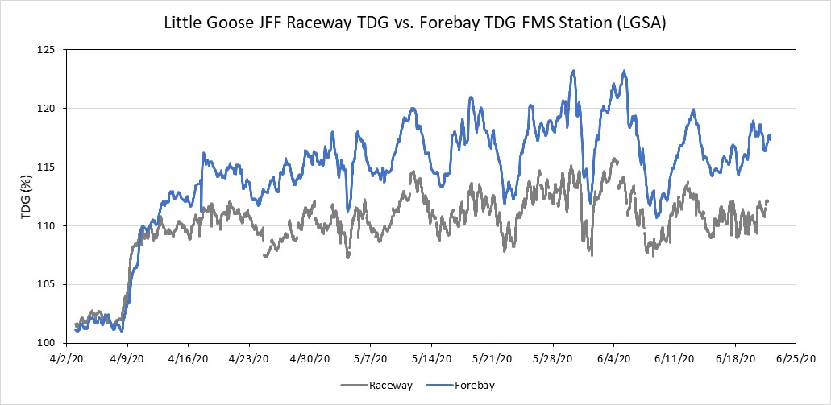

Figure 1. TDG in the raceway and forebay at Little Goose Dam from April 3 through June 21, 2020.

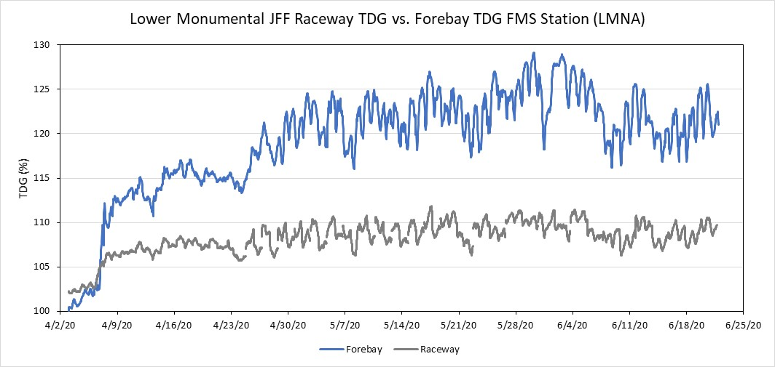

Figure 2. TDG in the raceway and forebay at Lower Monumental Dam from April 3 through June 21, 2020.

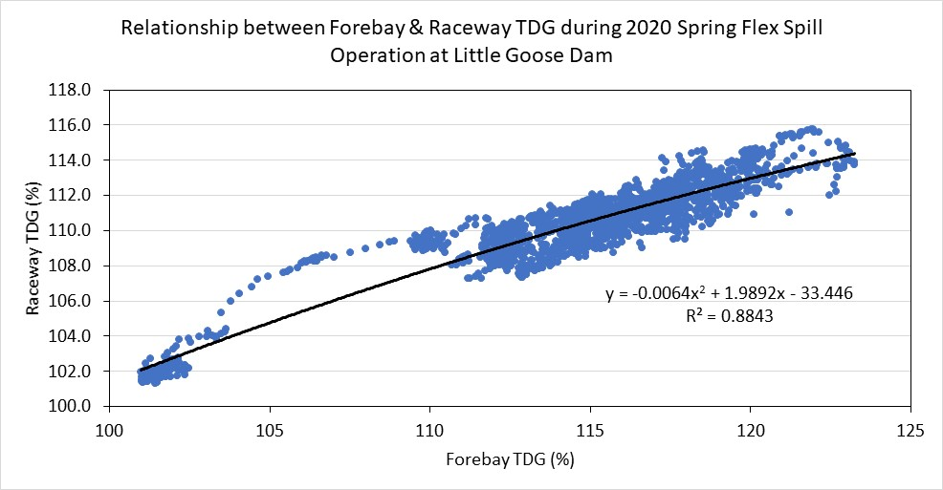

Figure 3. Relationship between forebay and raceway TDG levels at Little Goose Dam from April 3 through June 21, 2020.

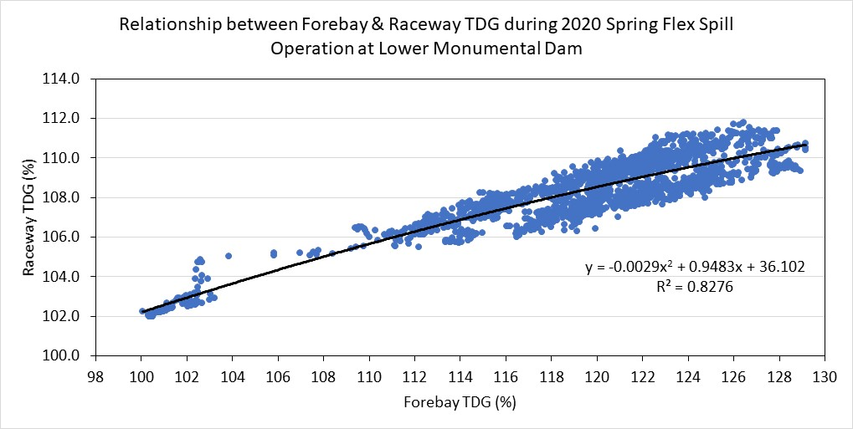

Figure 4. Relationship between forebay and raceway TDG levels at Lower Monumental Dam from April 3 through June 21, 2020.